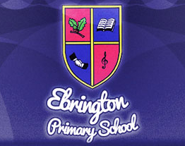
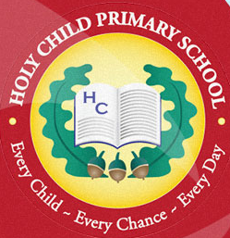
We pledge to grow the seed of peace in our hearts and so produce a rich harvest for the world.

Shared Education Newsletter
December 2016

We are delighted to bring you our Shared Education Newsletter, outlining some of the things we have got up to already in the exciting partnership which exists between Ebrington and Holy Child.
NURSERY: Nursery children got together in October for an Autumn walk in St Columb’s Park and afterwards for some fun in the play park. A great morning was had by all and reminded us that building good relationships between the children starts in the very earliest of years. Well done everyone! You are setting a great example to the other pupils in our schools.
PRIMARY SIX: October also saw the start of the second year of the ‘It Matters To Me’ Programme. Here the P6 children built on the friendships they had established in the Summer of P5 and in doing so, creatively explored the two important areas of Conflict and Reconciliation. The children all had great ideas to share and through walking debates, drama and group discussions, they learned that conflict will be inevitable in life. However, it is how you deal with it that matters. It was great to see the children tackling such tough issues so responsibly and sensitively. The children are looking forward to their Celebration Day in January.
KEY STAGE 1: As the Shared Education Programme expands, we hope there will be many opportunities for other children in the younger end of the schools to get involved. This term, for example, Ebrington welcomed Holy Child P3 and P4 children to see their Christmas Production.
NEXT TERM: The Primary Seven teachers are looking forward to beginning the next part of the Shared Education Programme in Term 2. Look out for information about how they get on, including pictures on the school websites. It promises to be a very worthwhile experience for all.
SHARED EDUCATION AT HOME: Parents! Please take the opportunity to discuss with your child what they get up to in their times of learning with their Partner School. Your attitude and interest in their experiences makes such a big difference to the success of this Programme. We so much enjoy your support in all this, but should anyone have any queries or concerns at any time, please do not hesitate to call in for a chat.
In the meantime, have a very Merry Christmas and a Happy New Year!
Yours sincerely,
Ms Orla Mc Donnell (Holy Child Primary School)
Mr Nigel Dougherty (Ebrington Primary School)

