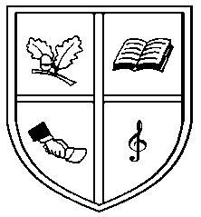
Ebrington Primary School

After School Club
(Mon – Fri)
2.00 – 5.00 pm
Fee £2 per hour
(Payable on every Friday for the following week)

(Nursery – P7)
All school children welcome
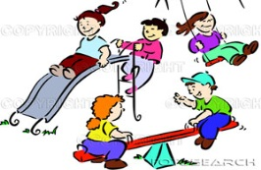
2.00 – 2.10pm | Children from Nursery through to P1 will be collected by a member of staff and toileted if necessary.
2.10 – 2.20pm | Children will be provided with a healthy snack; toast, pancake, fruit or biscuit and a drink of water or juice each day unless an activity is planned that needs to start at 2.15 pm. Other foods may be introduced during a special theme, activity or topic.
2.20 – 2.50 pm | Activity Time – Many daily activities will be provided for your child for example painting, sand/water, drawing/colouring, play dough and construction toys, white board & chalk board. Many other activities such as art & craft, cookery and games will be provided based around a theme or topic that the children may enjoy or do in school already.
2.50 – 3.00 pm | Tidying up time and settling down for home with a story or singing. All parents must collect their own children at 3.00 pm / 4.00 pm sharp unless other arrangements have been made with Mrs Brown – After School Club co-ordinator.
The Afterschool Club
Daily Routine

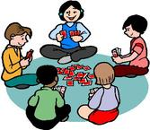

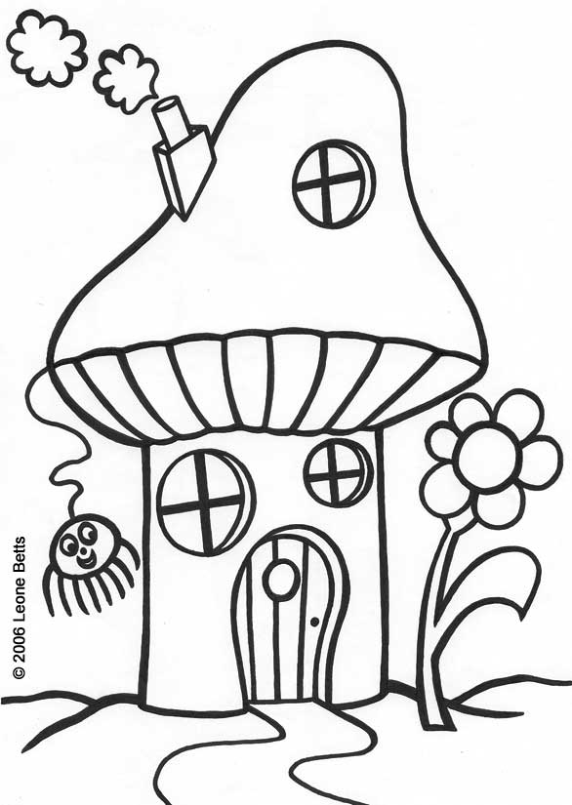
Please let your child colour in for his/her own amusement. – Thank you.

Visit our website on:
www.ebringtonps.co.uk
(To download Afterschool’s Policy, Registration Form, Booking Form and to preview photos etc).

School Telephone No: (028) 71 343864
Email address: wdougherty842@c2kni.net

