Ebrington Primary School

Fire Safety
Policy

Evacuation
Procedures

Fire Policy
Western Education and Library Board document on Fire Safety Management has been circulated to Staff. The new fire safety regulations came into force on 15 November 2010.

Mr Dougherty is the ‘Appropriate Person’. He must carry out a Fire Risk Assessment with the help of a Board Officer. This document must be regularly updated and readily available for inspection by Northern Ireland Fire & Rescue Service along with a Fire Safety Log Book. A fire contingency plan will also be drawn up.

All staff must be aware of how to raise the fire alarm and how to react when this has been activated. Training regarding use of fire extinguishers will be discussed periodically.

We are responsible for trying to prevent fires, including deliberate fires.

Some of the problems we may encounter if a fire breaks out:

Child out of class on learning support: | Teacher on learning support will be in charge.
Class split: | Assistant/Supervisor with other part of class responsible. These adults must be aware of procedures and must be aware of who is in school at any given time.
Child on errand or at toilet: | These children will be told to leave via nearest exit and find their class.

The school need to be zoned in order that children out of class may be picked up. An easily accessible class list should be stored in each classroom and collected as adults and children leave the room.

Some staff will be given extra training as Fire Wardens. The biggest concern is lunchtime, especially on certain days of the week when teachers go out for lunch.

Staff have been asked to consider zoning and how to fulfil their duty.

Senior Pupils: Evacuate building and assemble on field. Jillian Johnston Y6 Teacher will sweep the ground floor, Irene Stone will assist.

Sam → Gillian / Class (Lisa B)
Upstairs – Janice, cover Janine’s class.
Mobiles: Jonathan Moore will evacuate pupils then sweep all 3 mobile classrooms. → Children to field, classes to field.

Juniors: Brenda Cooke, Yr 3 Teacher, will sweep packed lunch room, platform, hall, music room, computer room and toilet. Christina will do sweep of Junior Corridor, Toilets and Stores. Speech & Language → children’s field.

Infants: Lorna Irwin, Yr2 Teacher, sweeps Y2 classrooms, empty store, toilets.
Classes to field. Joanne Anderson, Yr1 Teacher, sweeps/playroom, adults/disabled toilets, Speech & Language Room 1 and Therapy Room.
Christine Baggley, Yr1A, Yr1B & Yr2B pupils leave via infant entrance.
Shirley Pentland, Speech & Language Unit and Gael Butcher, Yr2A pupils
Leave via link corridor.

Office Staff: Nigel – sweep staff room;
Dawn & Heather: Lift visitors’ book, ensure fire doors are closed and leave via main entrance.

Nursery: Each teacher responsible for removing their own pupils by nearest exit and assistant will sweep rooms. They will inform office when they are off the premises.

All Teachers/Assistants to close as many doors as possible on vacating building.

Any adult with a child/group of children is responsible for their safe removal from the building.

In the event of a full school assembly:

Jonathan Torrens will open back doors – Yrs 5,6,7 will leave – 2 classes at a time. Yr 7’s will proceed down corridor, Yr 6’s out old front door, Yr 5’s proceed down corridor.

Foundation Stage pupils will move out through fire exit beside piano.

Yrs 3 & 4 will proceed up steps and decide whether going left or right.

Fire at Lunchtime:

Ask everyone to go on to playing fields.

Teacher on reflection takes children to field to join their class.
Canteen supervisors will open fire doors and move children from canteen to line up with their class on field. Supervisor in canteen will be responsible for canteen sweep.

Mrs Stanage and other available supervisors will be responsible for moving children in packed lunch room to the field.

Mr Dougherty, Principal and Mrs Stone, Vice Principal will keep all staff informed of outcome.

Updated 15th September 2015

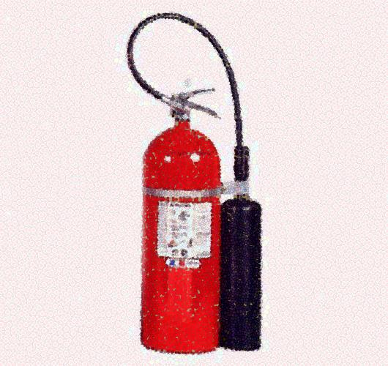

Fire Plan
Individual escape route for Jude Young.
Fire Drill
Escape plan for child using a wheelchair.

Infant end of school:
- Option 1 – Leave by school reception door.

- Option 2 – Leave through playroom to P1 door.

Junior end of school:

- Option 1 – Leave by door outside girls toilets, beside P3/P4 classrooms.
(ramp available).

- Option 2 – Leave by door in link corridor.

Senior end of school:
- Leave by door opposite P7 classroom to outside door.
(ramp available).
Sandra Bond (Special Needs Assistant)

Nigel Dougherty (Principal)

