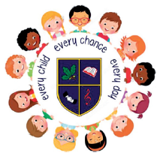

EBRINGTON PRIMARY SCHOOL
November 2023 Newsletter

Anti-Bullying Week

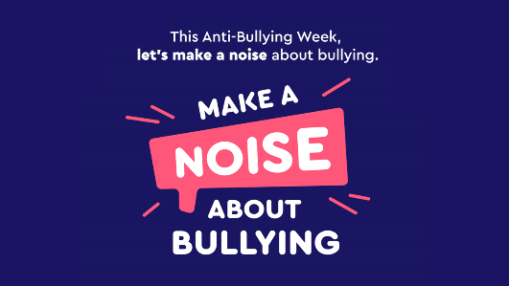
Next week will be national Anti-Bullying Week throughout the UK. The key message for this year is ‘Make A Noise About Bullying’, reminding us of who to ‘make a noise’ to if we have been affected by bullying, but also how we can ‘make a noise’ if we are aware of bullying happening. Classes will be engaged in a number of activities during the week, highlighting key issues.
To launch the week, we will have our ‘RED Day’ (Respect Everyone’s Differences) on Monday 13th November, as well as having two school assemblies on Monday (for FS & KS1) and Tuesday (for KS2).

School Closure due to non-teaching union strike action

It is with regret that school is closing on Thursday 16th November, having carried out a risk assessment to ensure the health, safety and wellbeing of pupils, staff and visitors on that day. The letter sent home explains this in more detail.

Christmas in school
This Photo by Unknown Author is licensed under CC BY-SA-NC

We are delighted to be looking forward to inviting parents and family in to school to various special events.

Foyle HUB Catering Christmas Tree decoration competition update-competition will be running again this year. More details to follow…get designing now!

Nursery Key Dates

Friday 9th December-Christmas jumpers/ clothes can be worn to Nursery.

A Nursery ‘Christmas Rhyme Time’ will be held in the school hall on Tuesday 12th December. Both Nursery classes will combine this year, with the big performance starting at 9:30am. We look forward to welcoming a large audience for this.
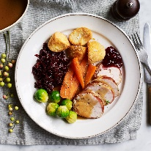
Christmas dinner for the Nursery pupils on Friday 15th December. Christmas jumpers can be worn on this day.
**Please note, the online booking menu will not be seen as the Christmas Dinner Menu, but please ensure you book dinner for that day, if you want your child to have the Christmas dinner.**

School Key Dates

Friday 9th December-Christmas jumpers/ clothes can be worn to primary school.

Week beginning Monday 11th December-Christmas Week in school. There will be a focus on the Christmas Story, as well as various crafts and activities to supplement learning. No homework will be set during this week.

Wednesday 13th December-Foundation Stage Christmas performance (P1 & P2), starting at 9:30 am-10:45 am approx.

Thursday 14th December-Key Stage 1 Christmas performance (P3 & P4), starting at 9:30 am-10:45 am approx.

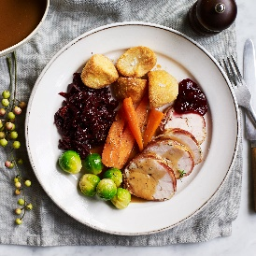
Christmas dinner for the Primary School pupils on Friday 15th December-menu will be coming out from Foyle Hub before the end of November, and a MS Forms will be sent to parents to book your menu choice.
**Please note, the online booking menu will not be seen as the Christmas Dinner Menu, but please ensure you book dinner for that day, if you want your child to have the Christmas dinner.**
**N.B. Christmas jumpers can be worn on this day.**
Friday 15th December-Christmas dinner for staff. To help us facilitate all staff coming together in the school hall, we will close school for all pupils @ 1:15pm on this day-there will be NO AFTER SCHOOL CLUB. Any payments already made will be refunded. I would like to thank parents for their support in this.

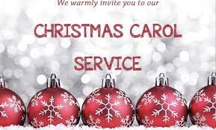
Carol Service
We are delighted to, once again, have the return of our school carol service. It will be held in Ebrington Presbyterian Church on Wednesday 20th December, starting at 10:00 am. This is a lovely way to bring our festive celebrations to an end and we would extend a welcome to all of our Ebrington family to join us there.

Term ends on Thursday 21st December @ 12 noon.

Christmas PTA Events

We are excited to announce the the PTA will be holding their annual Christmas raffle in December, with lots of great prizes on offer. Tickets will go out to families week beginning 4th December, with the draw taking place on Tuesday 19th December.

Supper with Santa

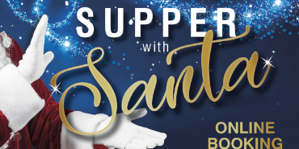
Also, during the week starting Monday 4th December, Friends fo Ebrington PTA will be holding a ‘Supper with Santa’ in school. This will be a pre-bookable event, held in the school hall, where pupils will have the chance to have supper with Santa, have him read a story and recieve a gift.

Londonderry Musical Society and Ebrington PS & NU
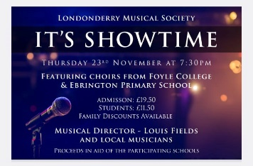
On Thursday 23rd November, our school choir are singing in the Millennium Forum, as part of the LMS anniversary celebrations. This promises to be a great event and if anyone is interested in tickets, please see Miss Caithness in the Nursery. LMS have kindly identified school as one of the charities to benefit from the event.
School start and finish times
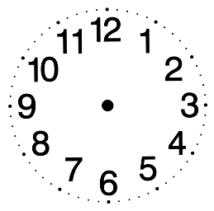
Thank you to everyone for doing their best to ensure pupils are in for school start time, at 8:50am. Classroom doors are locked after this time, and it puts considerable pressure on the front office at a busy time of the day, when pupils are brought to the front door. Please ensure your child attends school on time, as it also disrupts the start of the classroom routines when activities like going over homework/ reading/ spellings are completed.
We have the same families continually late-please make more of an effort to be on time!

SEAG

Reminder to P7 pupils/ parents that the Entrance Assessments will be held on the following dates:
Saturday 11th November 2023
Saturday 25th November 2023

We wish all our P7 pupils who are taking on these assessments the very best of luck. You have been working very well in school, so just do your best.

After School Club bookings
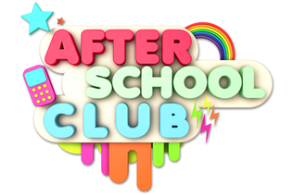
Parents-please remember to book your child for after school club and activitiy clubs at the correct time, to ensure we can have appropriate and safe levels of staff engaged.
Only in an emergency will a place be provided for a child, if no prior booking.

Dinner bookings
Please ensure dinner bookings are made by 11:59pm on the day prior to the dinner being requested..

Primary and Nursery Admissions January 2024

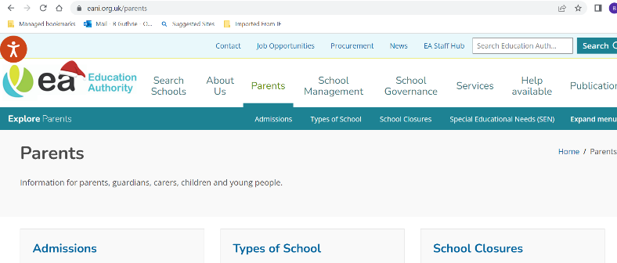
The EA Admissions ‘portal’ can be found at www.eani.org.uk/parents/admissions, and will open for applications for both Ebrington PS and Ebrington NU from 9th-26th January 2024 . For parents new to this process, this means parents making the application directly to EA, without involvement of school. An account needs to be set up with the portal and can be done prior to 9th January.
School has recently updated admissions criteria and sent to the EA. These will be published on the EA Admissions Portal. The onus will very much be on parents to ensure they initiate the procedure. Children born between 2 July 2019 and 1 July 2020 will be due to start Primary One in September 2024, while children born between 2 July 2020 and 1 July 2021 will be due to start Nursery in September 2024.

School Council

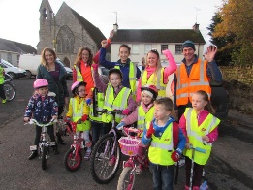
The School Council have had their first meeting and have decided on their term 1 fundraiser. They will be theming it on ‘Ditch the Dark Day’ on Friday 24th November (last Friday of the month). There will be a charge of £1per pupil, with pupils coming to school wearing bright colours to be seen in the darker mornings and evenings. (Council kindly adding a safety message in there too)

