#### 

#### EBRINGTON PRIMARY SCHOOL

**December 2023 Newsletter**

**Christmas in school**



[This Photo](https://shootingparrots.co.uk/2018/10/28/sunday-round-up-141/) by Unknown Author is licensed under [CC BY-SA-NC](https://creativecommons.org/licenses/by-nc-sa/3.0/)

We are **delighted** to be looking forward to inviting parents and family into school to various special events.

**Nursery Key Dates: REMINDER**

**Friday 9th December**-Christmas jumpers/ clothes can be worn to Nursery.

A Nursery ‘**Christmas Rhyme Time**’ will be held in the school hall on **Tuesday 12th December. Both Nursery classes will combine this year, with the big performance starting at 9:30am.** We look forward to welcoming a large audience for this.

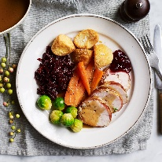

**Christmas dinner** for the Nursery pupils on **Friday 15th December.** Christmas jumpers can be worn on this day.

**Please note**, the online booking menu will not be seen as the Christmas Dinner Menu**, but please ensure you book dinner for that day, if you want your child to have the Christmas dinner.**

Ms Forms has been sent by text to parents. Please still remember to book on the SchoolMoney App

**School Key Dates: REMINDER**

**Friday 8th December**-Christmas jumpers/ clothes can be worn to primary school.

Week beginning Monday 11th December-Christmas Week in school. There will be a focus on the Christmas Story, as well as various crafts and activities to supplement learning. No homework will be set during this week.

**During this week, children do not need to come in to school wearing uniform. They can wear clothes of their own, which can be Christmassy or not. Please remember though, we want everyone in a Christmas jumper/ top/ dress on both Fridays, 8th & 15th December.**

**Wednesday 13th December**-Foundation Stage Christmas performance (P1 & P2), starting at 9:30 am-10:45 am approx.

**Thursday 14th December**-Key Stage 1 Christmas performance (P3 & P4), starting at 9:30 am-10:45 am approx.

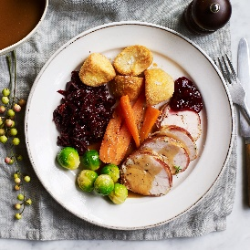**Christmas dinner** for the Primary School pupils on **Friday 15th December**-menu will be coming out from Foyle Hub before the end of November, and a MS Forms will be sent to parents to book your menu choice.

**Please note, **the online booking menu will not be seen as the Christmas Dinner Menu,** but please ensure you book dinner for that day, if you want your child to have the Christmas dinner.**

**\*\*N.B. Christmas jumpers to be worn on this day.\*\***

**Friday 15th December**-Christmas dinner for staff. To help us facilitate all staff coming together in the school hall, **we will close school for all pupils @ 1:15pm on this day-there will be NO AFTER SCHOOL CLUB**. Any payments already made will be refunded. I would like to thank parents for their support in this.

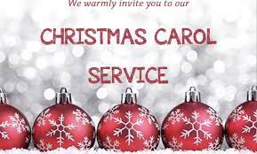**Carol Service**

We are delighted to, once again, have the return of our school carol service. **It will be held in Ebrington Presbyterian Church on Wednesday 20th December, starting at 10:00 am.** This is a lovely way to bring our festive celebrations to an end and we would extend a welcome to all of our Ebrington family to join us there.

**Term ends on Thursday 21st December @ 12 noon.**

**Christmas PTA Events**

We are excited that the PTA are holding their annual Christmas raffle in December, with lots of great prizes on offer. Tickets have gone out to families this week, with the draw taking place on Tuesday 19th December. If families would like additional tickets, they can be provided by contacting/ calling with the school office.

**Supper with Santa**

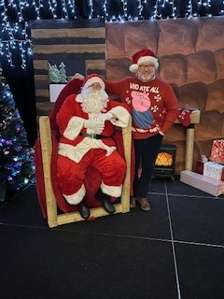

A massive **THANK YOU** to all who came to our Supper with Santa last night, Wednesday 6th December. It was an amazing night full of fun and magic. It was just delightful to see so many of our Ebrington community being able to take time to socialise with each other. A big **THANK YOU** to Santa for making the trip down from the North Pole. Boys and girls…he has said he might have to pop back down before the Christmas break to speak to Mr Guthrie-keep up the good work and put on amazing shows over the next two weeks please.

**After School Club bookings**

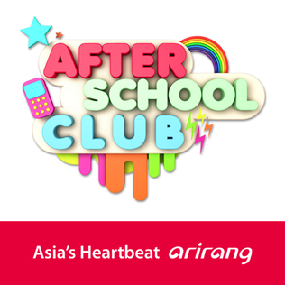

Parents-**please remember to book your child for after school club and activitiy clubs at the correct time**, to ensure we can have appropriate and safe levels of staff engaged.

Only in an absolute emergency will a place be provided for a child, if no prior booking. Staff will simply have to refuse if no prior booking is evident.

**Primary and Nursery Admissions January 2024**

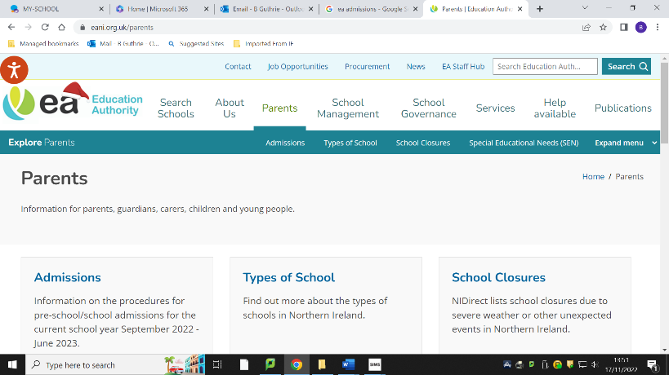The EA Admissions ‘portal’ can be found at [www.eani.org.uk/parents/admissions](http://www.eani.org.uk/parents/admissions), and will open for applications for both Ebrington PS and Ebrington NU from 9th-26th January 2024 . For parents new to this process, this means parents making the application directly to EA, without involvement of school. An account needs to be set up with the portal and can be done prior to 9th January.

School has recently updated admissions criteria and sent to the EA. These will be published on the EA Admissions Portal. The onus will very much be on parents to ensure they initiate the procedure. Children born between 2 July 2019 and 1 July 2020 will be due to start Primary One in September 2024, while children born between 2 July 2020 and 1 July 2021 will be due to start Nursery in September 2024.

As we approach the end of the term, can I just thank you all for your support throughout not just this term but throughout 2023. It has been a challenging year in schools, with so many budget cuts and initiative cuts, but we have still tried to ensure we provide the pupils with a broad and balanced curriculum.

**On behalf of the staff of Ebrington PS & NU, could I please take this opportunity to wish you and yours a warm, relaxing family and friends-orientated Christmas, and wish you every blessing for the new year, 2024, as it approaches.**



